**Name :** Yen-Ting Liu (ytliu2)

**Part-1 : Linear Interpolation**

1. Insert your linear interpolated test image(hope.jpg) here: **A picture containing outdoor, person

   Description automatically generated**
2. Display the map/plot of all the 3 training images here:

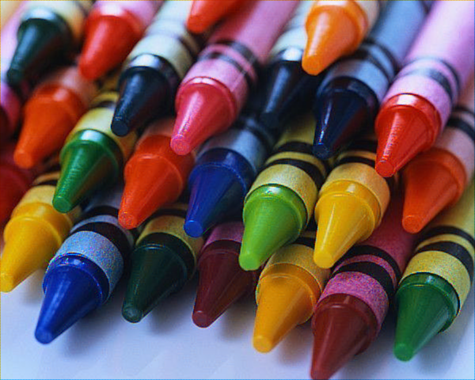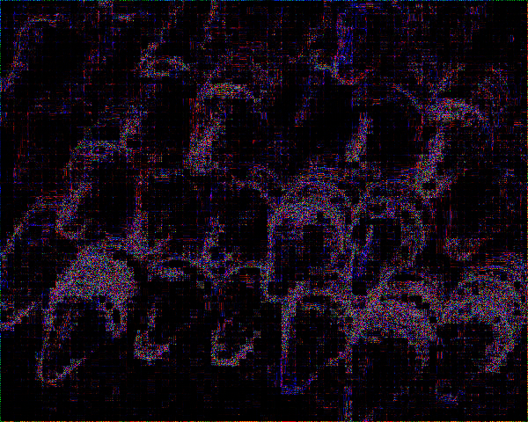

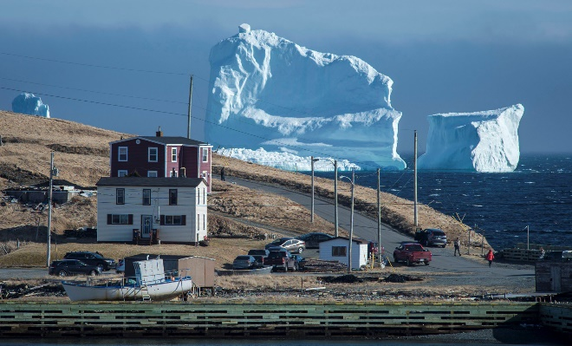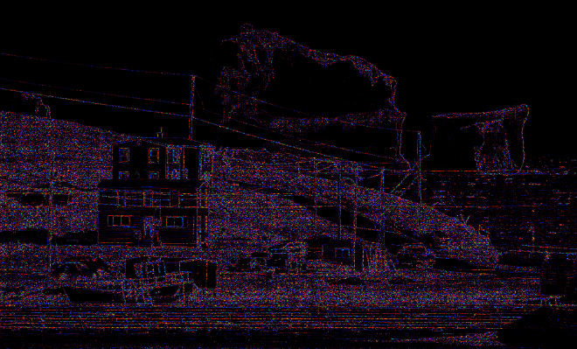

1. Post close-up of any artifacts you came across.

X0=(41,281); (W,H)=(124,124)

X0=(781,733); (W,H)=(126,126)

 X0=(540,209); (W,H)=(73,73)

1. Average_per_pixel error and Max_pixel_error for each of 3 training images :

|  |  |  |
| --- | --- | --- |
| **Image** | **Average_per_pixel_error** | **Max_pixel_error** |
| Crayons | 16.29 | 249 |
| Iceberg | 14.75 | 249 |
| Tony | 5.17 | 249 |

**Part-2 : Freeman Method**

1. Insert your Freeman Method test image(hope.jpg) here:

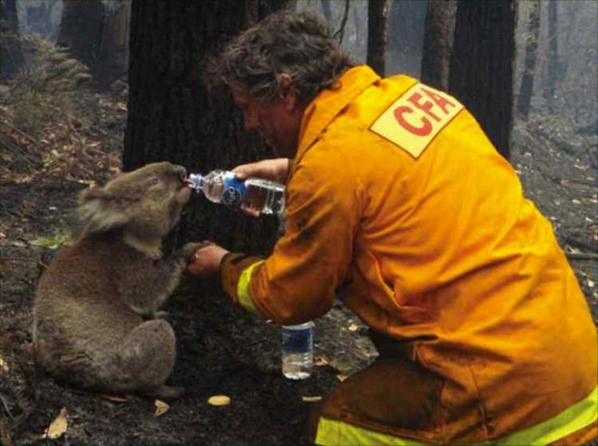

1. Display the map/plot of all the 3 training images here:

(All Freeman method reconstructions below use median filter with kernel size (3, 3).)

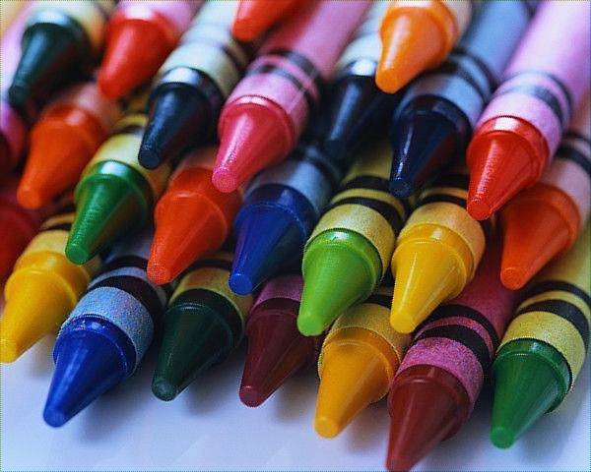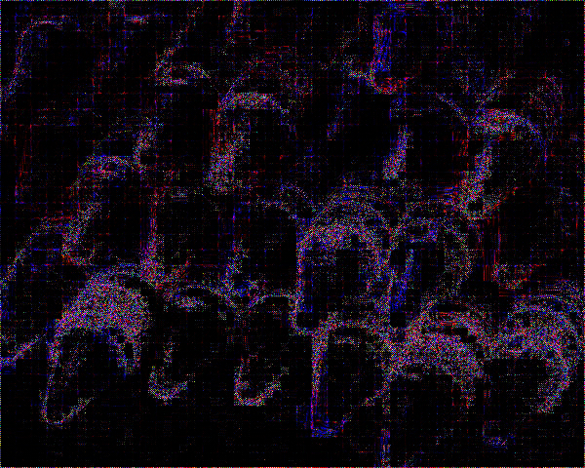

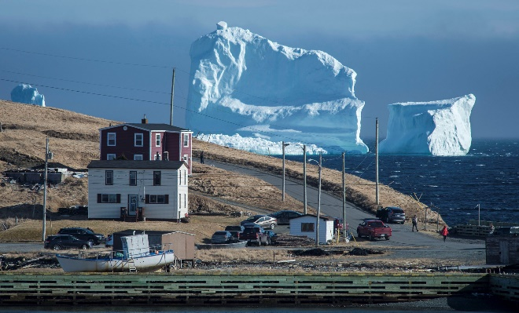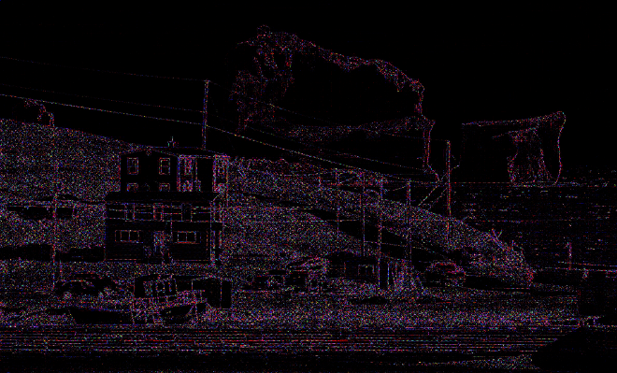

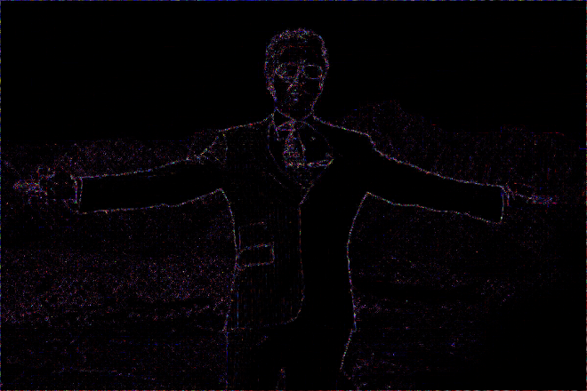

1. Post close-up of any artifacts you came across.

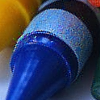 X0=(41,281); (W,H)=(124,124)

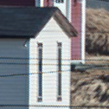 X0=(781,733); (W,H)=(126,126)

 X0=(540,209); (W,H)=(73,73)

1. Average_per_pixel error and Max_pixel_error for each of 3 training images :

|  |  |  |
| --- | --- | --- |
| **Image** | **Average_per_pixel_error** | **Max_pixel_error** |
| Crayons | 15.49 | 249 |
| Iceberg | 12.79 | 249 |
| Tony | 4.28 | 249 |

**Part-3 : Images of your choice**

1. Post 2 images of your choice here and the corresponding error maps of your outputs with the Freeman method.

(Following colored images are reconstructed results.)

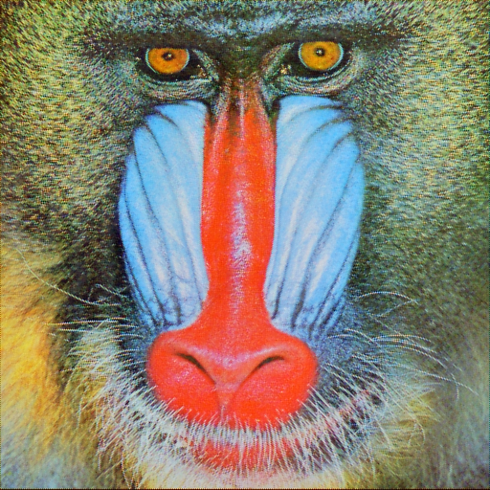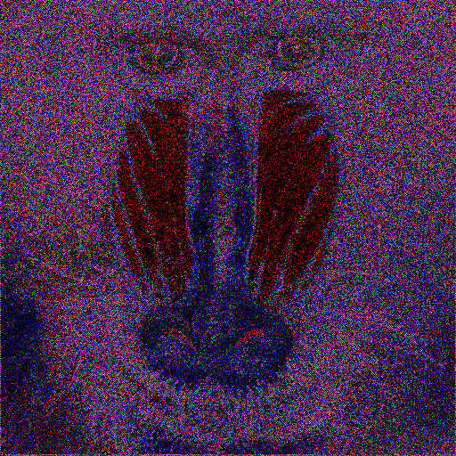

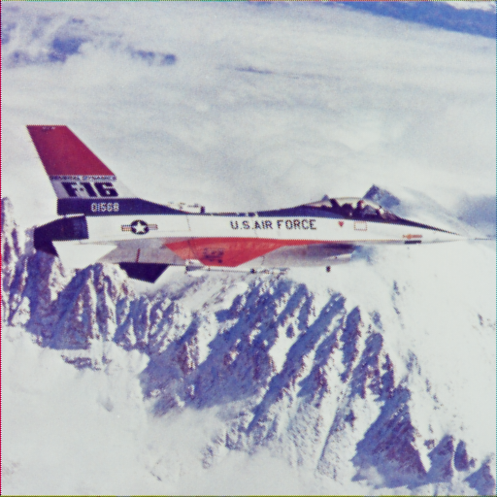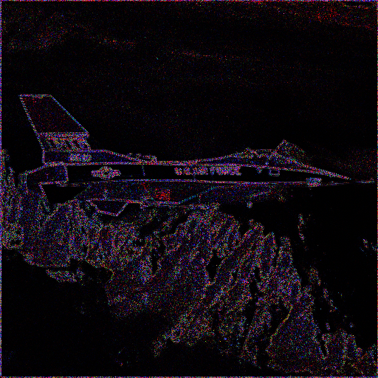

1. Any image that breaks the method and why do you think so?

Based on the observation in `Tony`, demosaicing tends to fail around sharp edges. My assumption is that sharp edges are lost when doing mosaicing, doing linear interpolation is essentially a low pass filter on the image, therefore, color restoration around these parts will fail.

Freeman method tries to avoid restoration error by using green channel (which has twice the number of pixels), therefore, smooth regions should have superior performance. However, long, sharp features are not fixable this, this is visible in `Iceberg` where the cable still has zippering artifact.

Therefore, I choose these two images from the SIPI database

* baboon (4.2.03) has lots of sharp color transitions.
* airplane (4.2.05) has uniform cloud background and lots of ridges at its bottom.

Results agree with the observation, where uniform background yields near perfect reconstruction, where rough edges (sharp color transitions) failed despite additional efforts to fix them.

**Part-4 : Bonus**

Post any extra credit details/images/references used here.